**פתרון תרגילים מחוברת תרגילים**

**פרק 19 - Indexes and Statistics**

1.

CREATE NONCLUSTERED INDEX [nc_MemberId_Login]

ON [Operation].[MemberSessions] ([MemberId] ASC, [LoginDateTime] ASC)

WITH (FILLFACTOR = 80) ON [PRIMARY]

2.

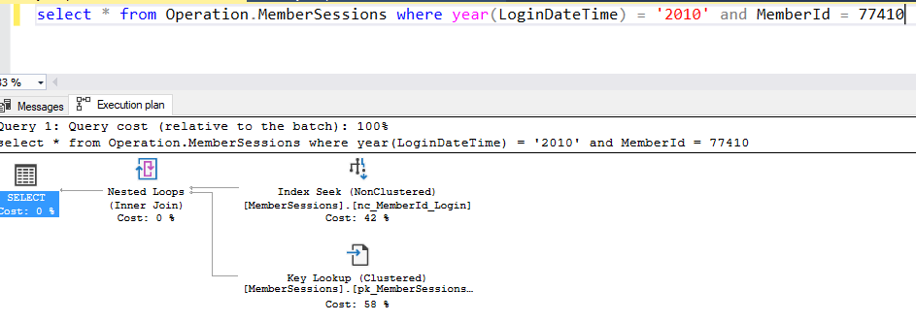

3.

select mss.*

from Operation.MemberSessions mss with (forceseek, index(nc_MemberId_Login))

join Operation.Members m on mss.MemberId = m.Id

where DATEDIFF(yy,BirthDate,GETDATE()) = 25 and m.GenderId = 2 and m.MaritalStatusId = 1

order by m.Id,mss.LoginDateTime

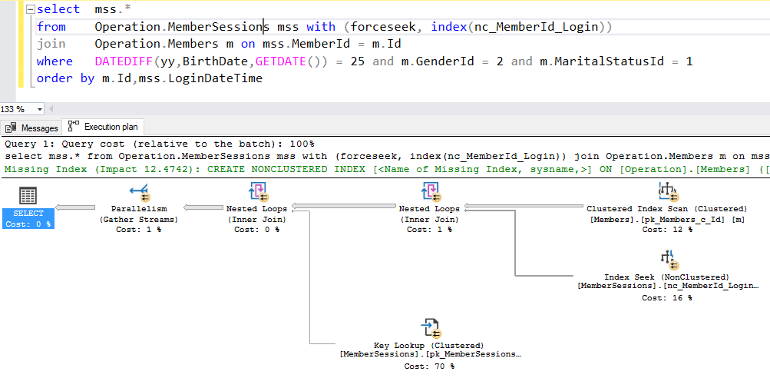

4.

CREATE UNIQUE NONCLUSTERED INDEX [nc_usn_pwd] ON [Operation].[Members]

(

[Username] ASC,

[Password] ASC

)

5.

select * from Operation.Members where Username = 'XXXX' AND Password = '1359399'

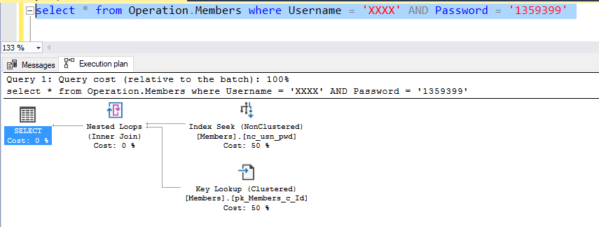

6.

The index above prevents insertion/update of same user and password

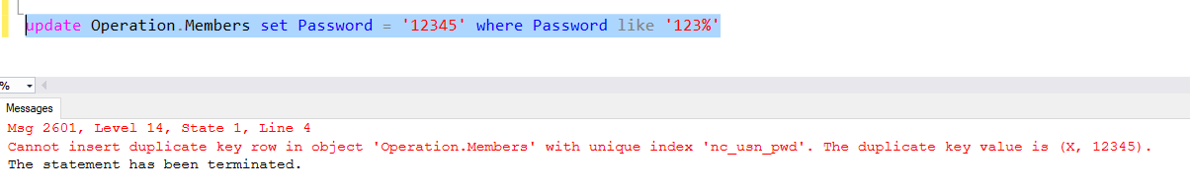

7.

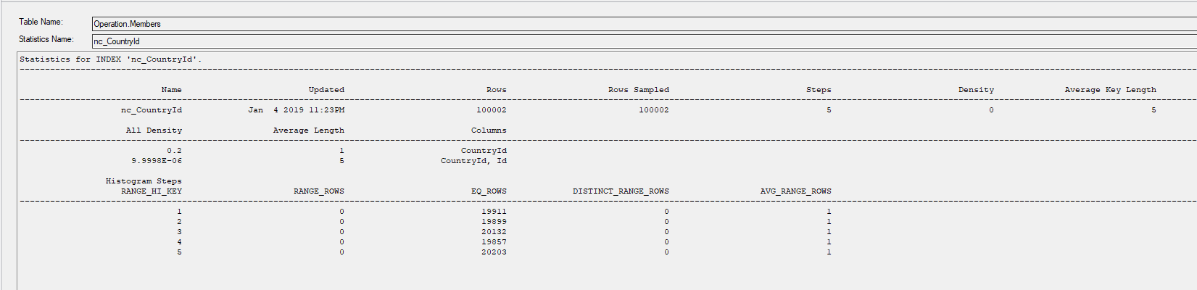

8.

select *

from Operation.Invitations i

join Operation.MemberSessions ms on i.RequestingSessionId = ms.Id

join Operation.Members m on ms.MemberId = m.Id and FirstName = 'Paul' and LastName = 'Simon'

Adding index on First and Last names:

create nonclustered index nc_fn_ln on [Operation].[Members] (FirstName asc,LastName asc) ON [PRIMARY]

9.

select *

from Operation.Members with (forceseek, index ([pk_Members_c_Id]))

where Id not in (5,6,7,8)

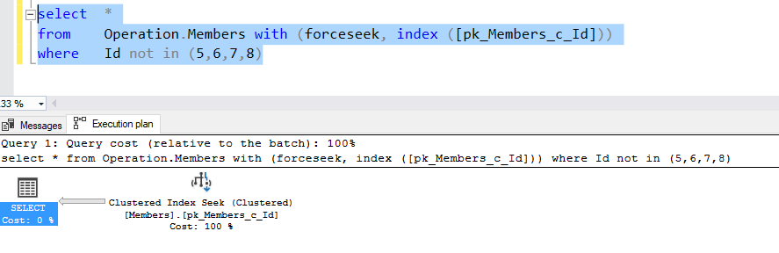

10.

select FirstName,LastName

from Operation.Members

where LastName like 'B%'

order by FirstName,BirthDate

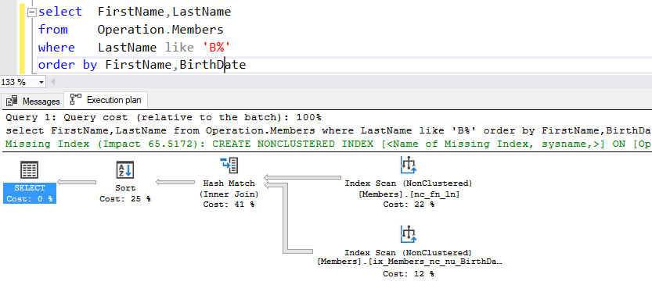

There is no seek index, because it is built on the first name and not on the last name, so sql still need to scan all the rows.

If I change my existing index and switch the last name and first name, it will search with index seek:

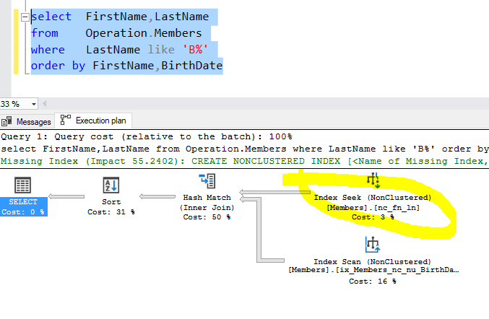

11. In order to improve search we can reverse the Last Name:

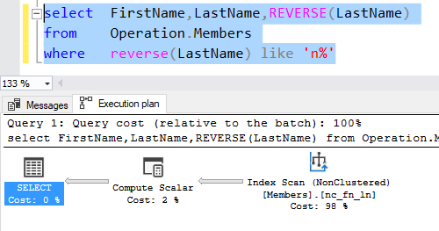

12. The only way to use index on substring is to build a separate calculated column and build index on it:

select FirstName,LastName,EmailAddress,

SUBSTRING(EmailAddress,

CHARINDEX('@',EmailAddress)+1,

LEN(EmailAddress)-CHARINDEX('@',EmailAddress)+1)

from Operation.Members

13. In order to improve the query I added the column StreetAdress to the exisitng index [ix_Members_nc_nu_BirthDate#GenderId#SexualPreferenceId]:

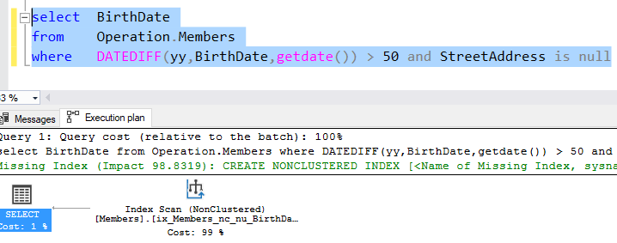

14.

ALTER TABLE [Operation].[Members] ADD CONSTRAINT [pk_Members_c_Id] PRIMARY KEY CLUSTERED ([Id] ASC)

WITH (FILLFACTOR = 100) ON [PRIMARY]

15.

CREATE NONCLUSTERED INDEX [NC_EndDateTime_EndReasonId_MemberId] ON [Operation].[MemberSessions]

(

[EndDateTime] ASC,

[EndReasonId] ASC

)

INCLUDE ([MemberId]) WITH (FILLFACTOR = 80) ON [PRIMARY]

16.

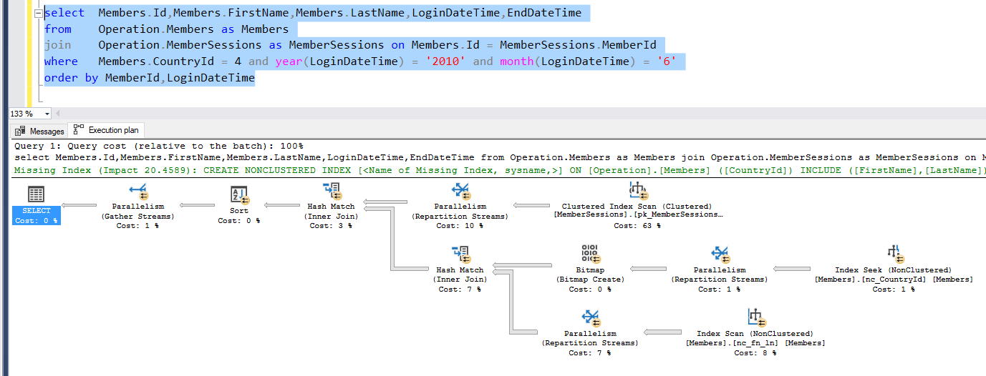

17. In order to improve I've added included columns First and Last Names to the existing index on CountryId:

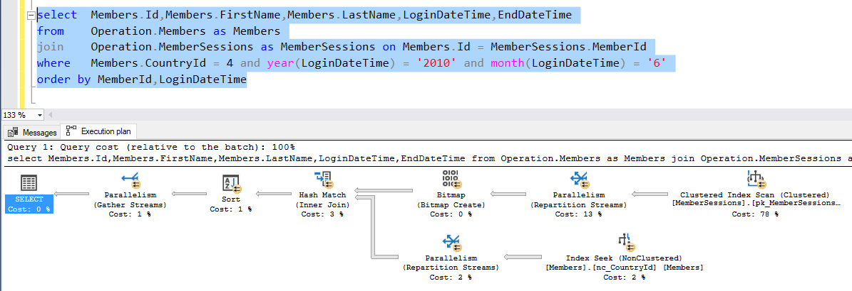

18.

select s.name as SchemaName,t.name as TableName,i.name as IndexName,

i.type_desc as IndexType,i.is_unique as IsUnique,i.fill_factor as FillFactorValue

from sys.indexes i

join sys.tables t on i.object_id = t.object_id

join sys.schemas s on t.schema_id = s.schema_id

19.

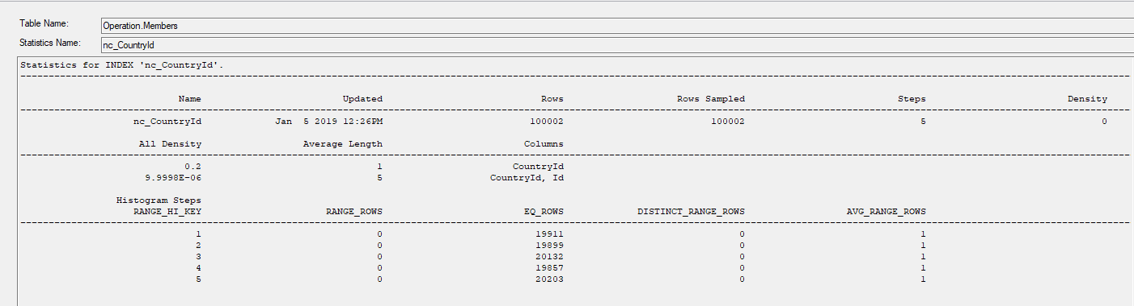

20.

create table CheckFillFactor(col nvarchar(100) not null)

--insert values

declare @i int = 0, @text nvarchar(100) = 'a';

while @i < 1000

begin

insert into CheckFillFactor values (CONCAT(@text,cast(@i as nvarchar)))

set @i = @i + 1

end

--test inserted values

select * from CheckFillFactor order by col desc

--create non-clustered index with 80% fill factor

CREATE NONCLUSTERED INDEX [NC_80] ON [dbo].[CheckFillFactor]([col] ASC)

WITH (FILLFACTOR = 80) ON [PRIMARY]

--create non-clustered index with 10% fill factor

CREATE NONCLUSTERED INDEX [NC_10] ON [dbo].[CheckFillFactor] ([col] ASC)

WITH (FILLFACTOR = 10) ON [PRIMARY]

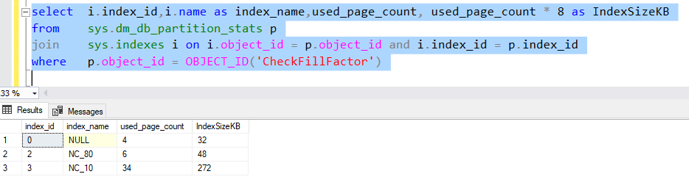

21.

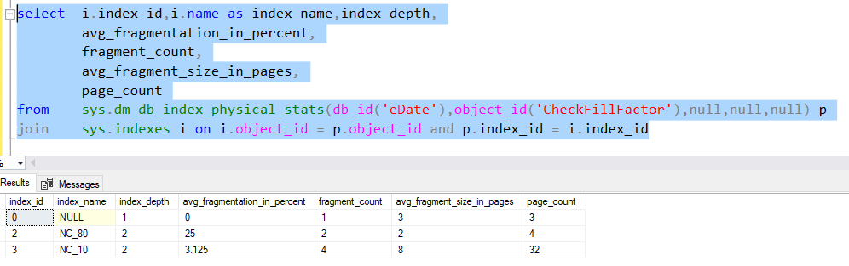

22.

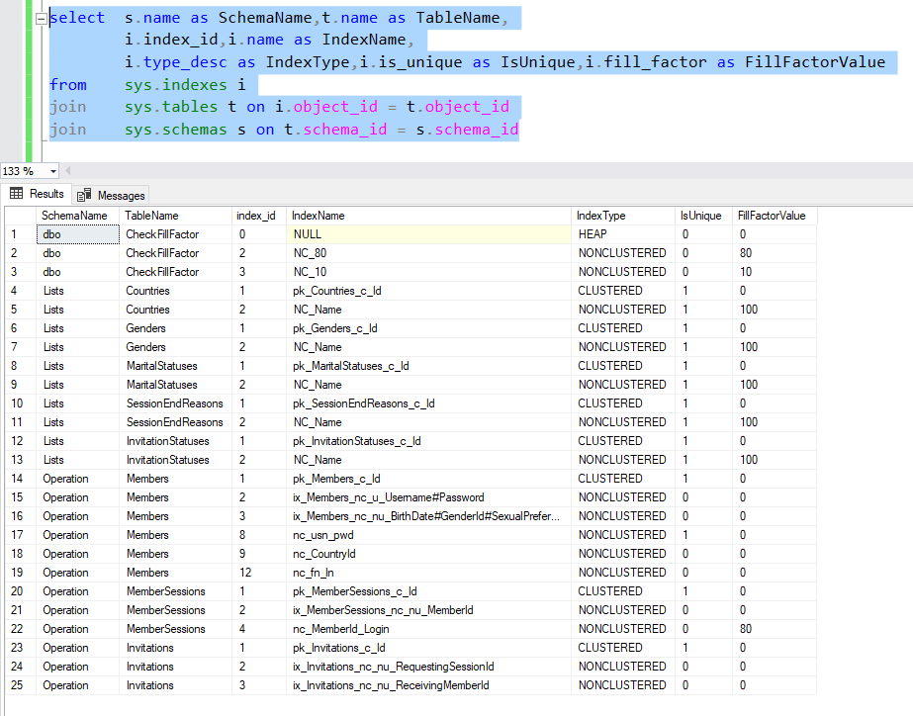

23.

create table TestTable(col_a char(10) not null)

--insert values

declare @i int = 0;

while @i < 10000

begin

insert into TestTable (col_a) values ('A')

set @i = @i + 1

end

--add new calculated column

alter table TestTable add calculated_a as col_a+col_a

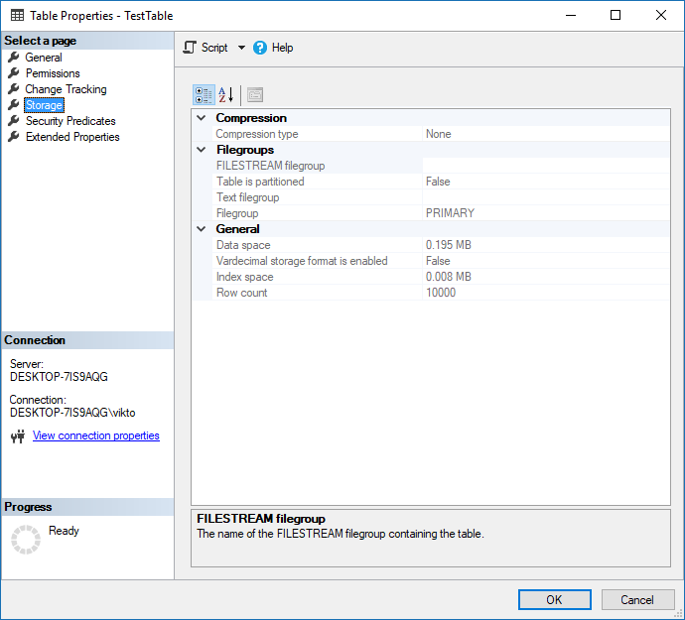

--add new persisted calculated column

alter table TestTable add persisted_a as col_a+col_a persisted

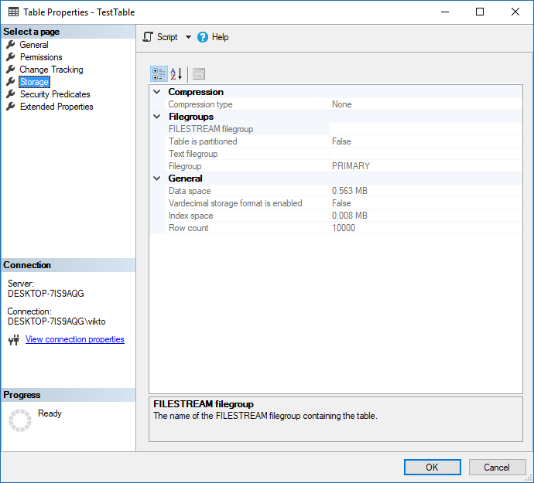

24. Birthday is not null - correct for filtered index

Birthday like '2003' - possible but not useful, filter index has benefits when it uses simple where clauses and can filter most of the data from table or when it retrieves the most common queries.

25.

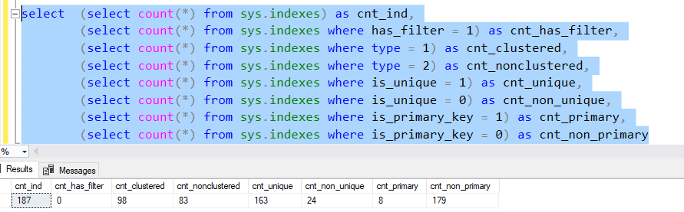

26.

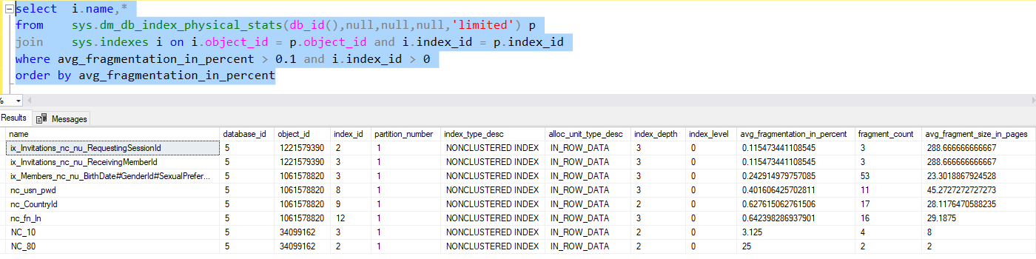

DECLARE @index_name nvarchar(100),@table_name nvarchar(100),@avg float

DECLARE cur CURSOR FOR

select i.name as index_name,s.name+'.'+t.name as table_name,avg_fragmentation_in_percent

from sys.dm_db_index_physical_stats(db_id(),null,null,null,'limited') p

join sys.indexes i on i.object_id = p.object_id and i.index_id = p.index_id

join sys.tables t on i.object_id = t.object_id

join sys.schemas s on t.schema_id = s.schema_id

where avg_fragmentation_in_percent > 0.1 and i.index_id > 0

OPEN cur

FETCH NEXT FROM cur INTO @index_name,@table_name,@avg

WHILE @@FETCH_STATUS = 0

BEGIN

if @avg >= 0.3

BEGIN

PRINT 'avg_fragmentation_in_percent = ' + cast(@avg as nvarchar);

PRINT 'alter index' + @index_name + ' on ' + @table_name + ' rebuild';

END

else

BEGIN

PRINT 'avg_fragmentation_in_percent = ' + cast(@avg as nvarchar);

PRINT 'alter index' + @index_name + ' on ' + @table_name + ' reorganize';

END

FETCH NEXT FROM cur INTO @index_name,@table_name,@avg;

END

CLOSE cur;

DEALLOCATE cur;

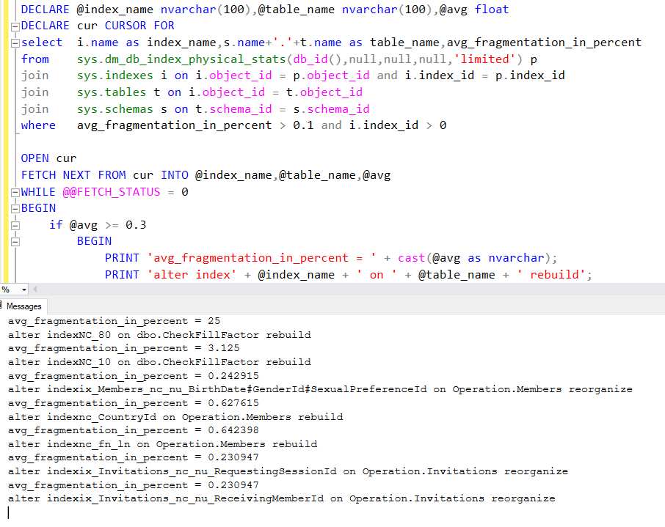

27.

create table #temp_table(table_name nvarchar(100),column_name nvarchar(100))

declare @table nvarchar(100),@column nvarchar(100);

declare c2 cursor for

select t.name as table_name,c.name as col_name

from sys.tables t

join sys.indexes i on t.object_id = i.object_id

join sys.index_columns ic on i.index_id = ic.index_id and i.object_id = ic.object_id

join sys.columns c on ic.column_id = c.column_id and c.object_id = t.object_id

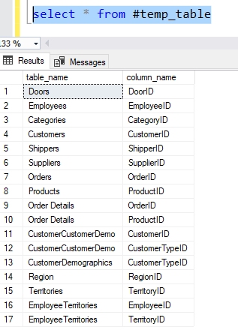where i.is_primary_key = 1

OPEN c2

FETCH NEXT FROM c2 INTO @table,@column

WHILE @@FETCH_STATUS = 0

begin

print @table + ' ' + @column;

insert into #temp_table values(@table,@column);

FETCH NEXT FROM c2 INTO @table,@column;

end

CLOSE c2;

DEALLOCATE c2;

28.

select t.name as TableName,

i.index_id,i.name as IndexName,

i.type_desc as IndexType,

case when i.is_unique = 1 then 'Unique' else 'Non-Unique' end as IsUnique,

o.create_date,

s.user_seeks,s.user_scans

from sys.indexes i

join sys.tables t on i.object_id = t.object_id

join sys.objects o on i.name = o.name

left join sys.dm_db_index_usage_stats s on s.index_id = i.index_id and s.object_id = t.object_id

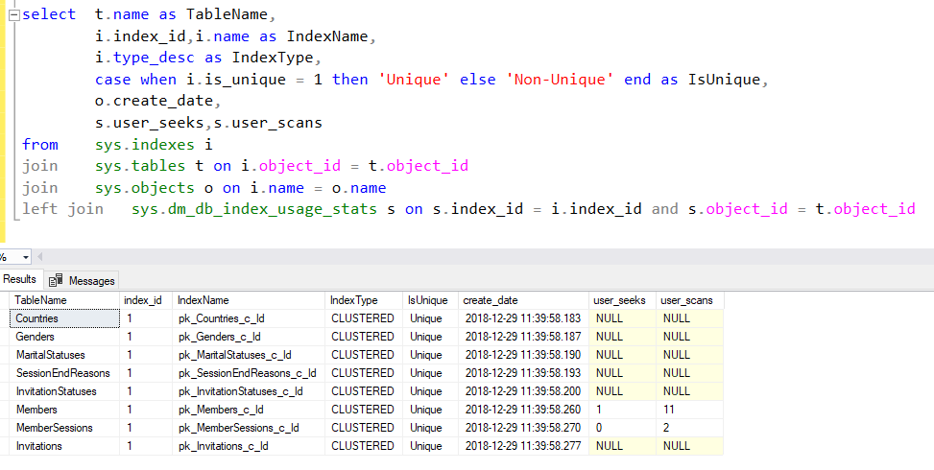

29.

CREATE NONCLUSTERED INDEX [NC_Postal_Code] ON [Person].[Address] ([PostalCode] ASC) ON [PRIMARY]

Before adding included columns: 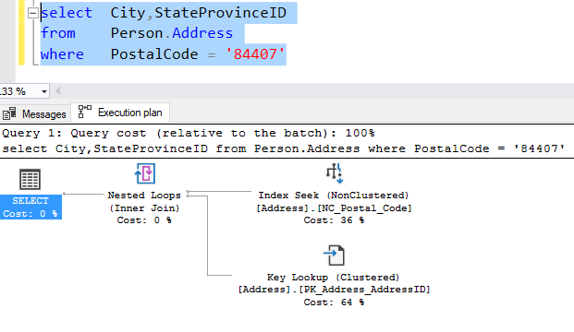

After index update with adding columns: 